Lab task 9.1

Exercise 1

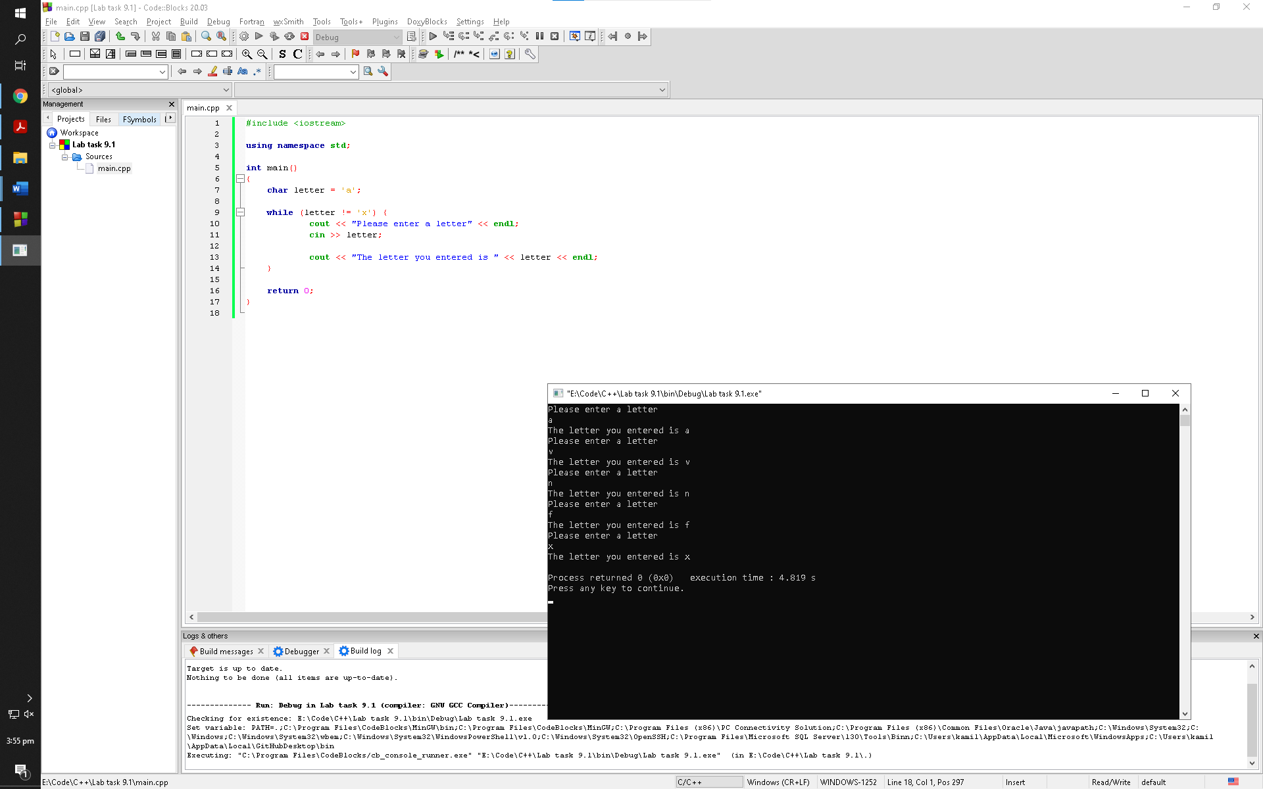

Observation: The program loops around in the while loop until the user enters a particular character to abort the program. The user is not aware of the character since it is not described in the program. We as programmers can see what the character is but the user is not presented with a screen that shows the code for the program hence making the program not user friendly

Exercise 2

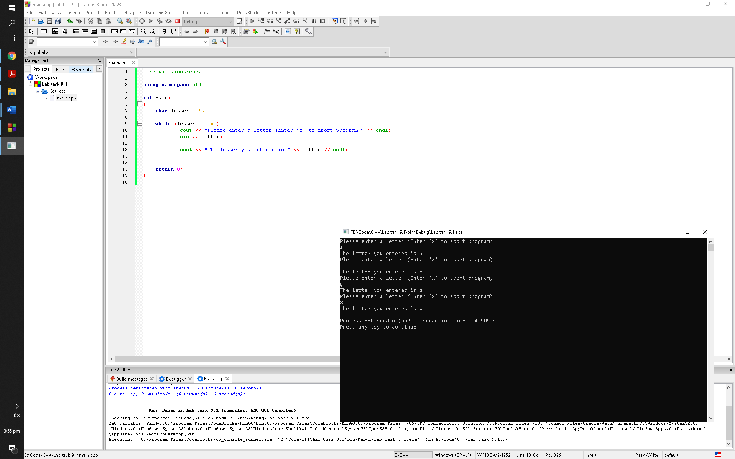

Observation: The program loops around in the while loop until the user enters a particular character to abort the program. The user is aware of the character since it is described in the program this time hence making this program user friendly

Exercise 3

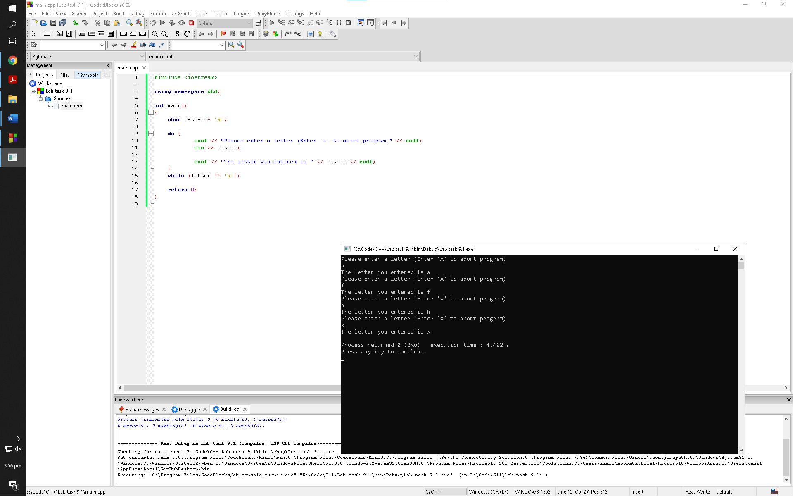

Observation: The program loops around in the do while loop until the user enters a particular character to abort the program. In this loop the program first processes the commands and then checks for the condition whether it’s true or not

Lab task 9.2

Exercise 4

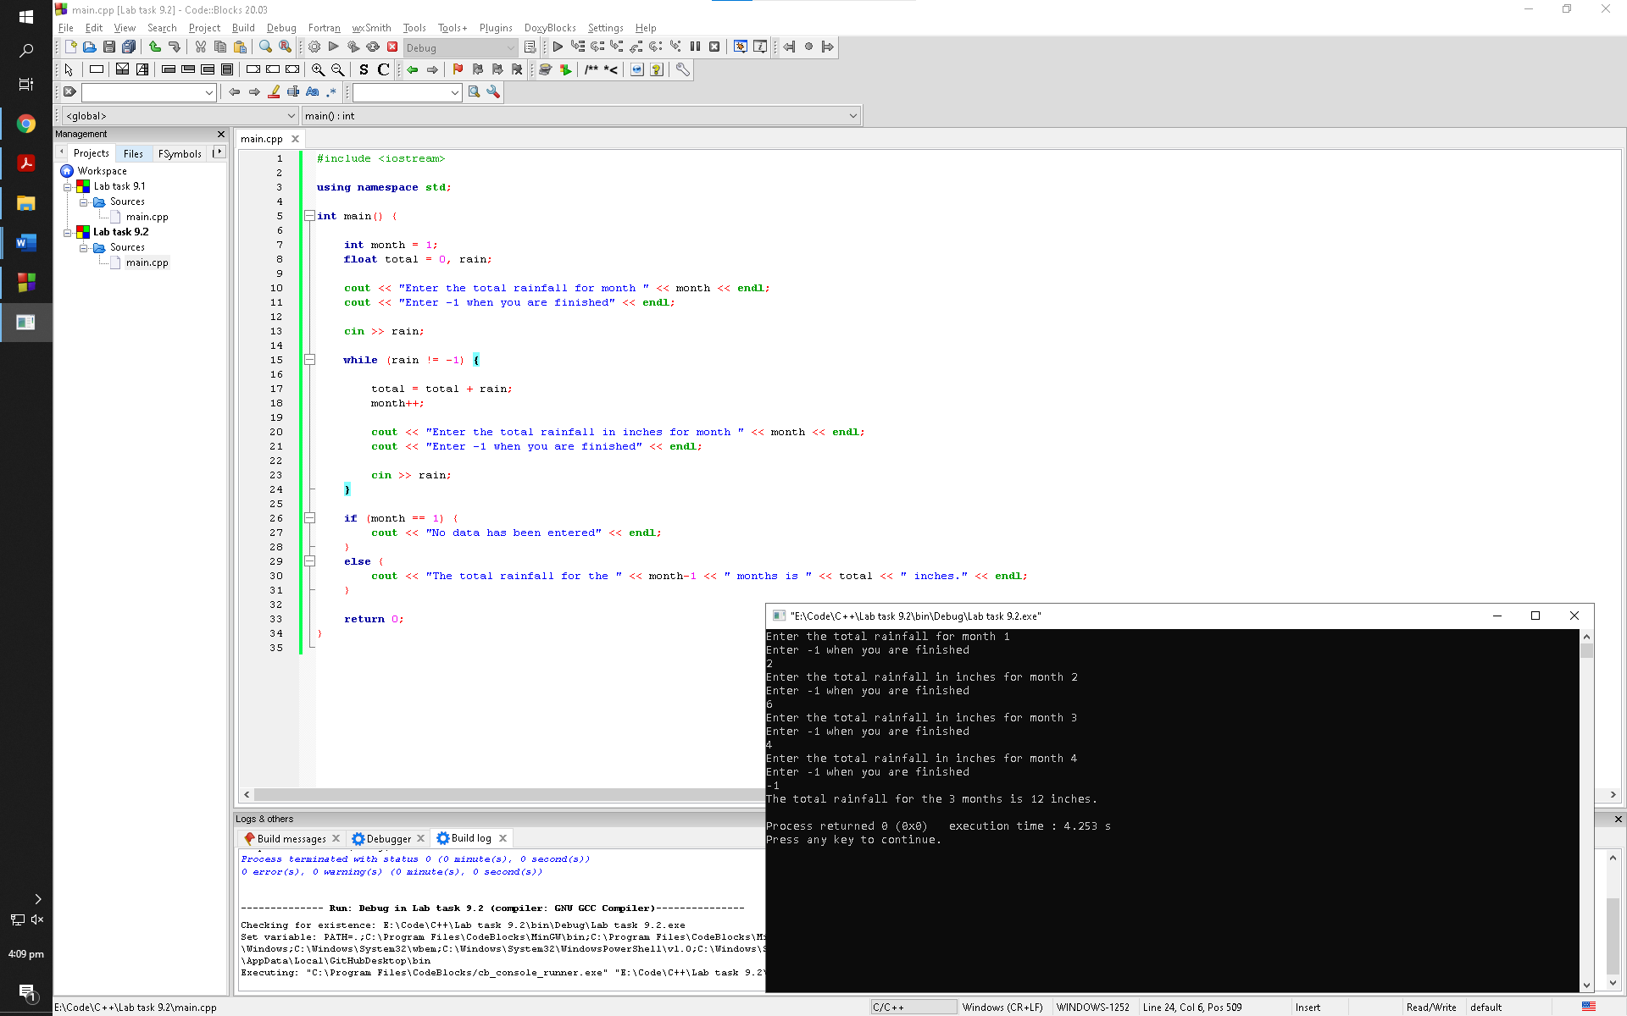

Observation: The program asks the user for the amount of rainfall for as many months as the user would like to enter values of. The program adds all the values of rainfall by using a while loop until he/she enters “-1” to abort the loop and prompts the user with the total rainfall with respect to the months the user entered

Exercise 5

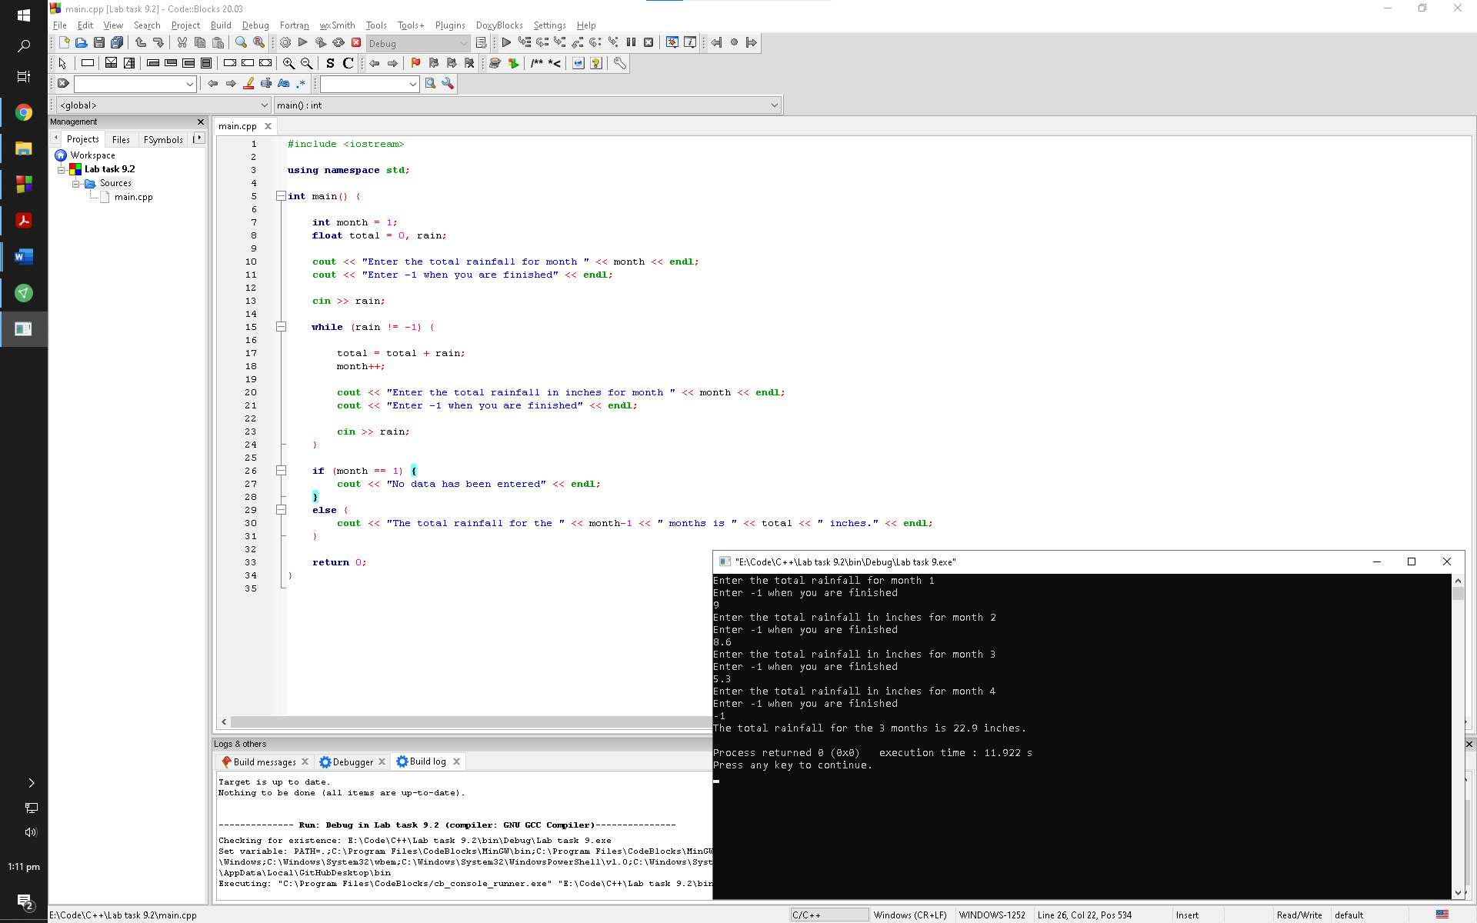

What happens if you enter –1 first?

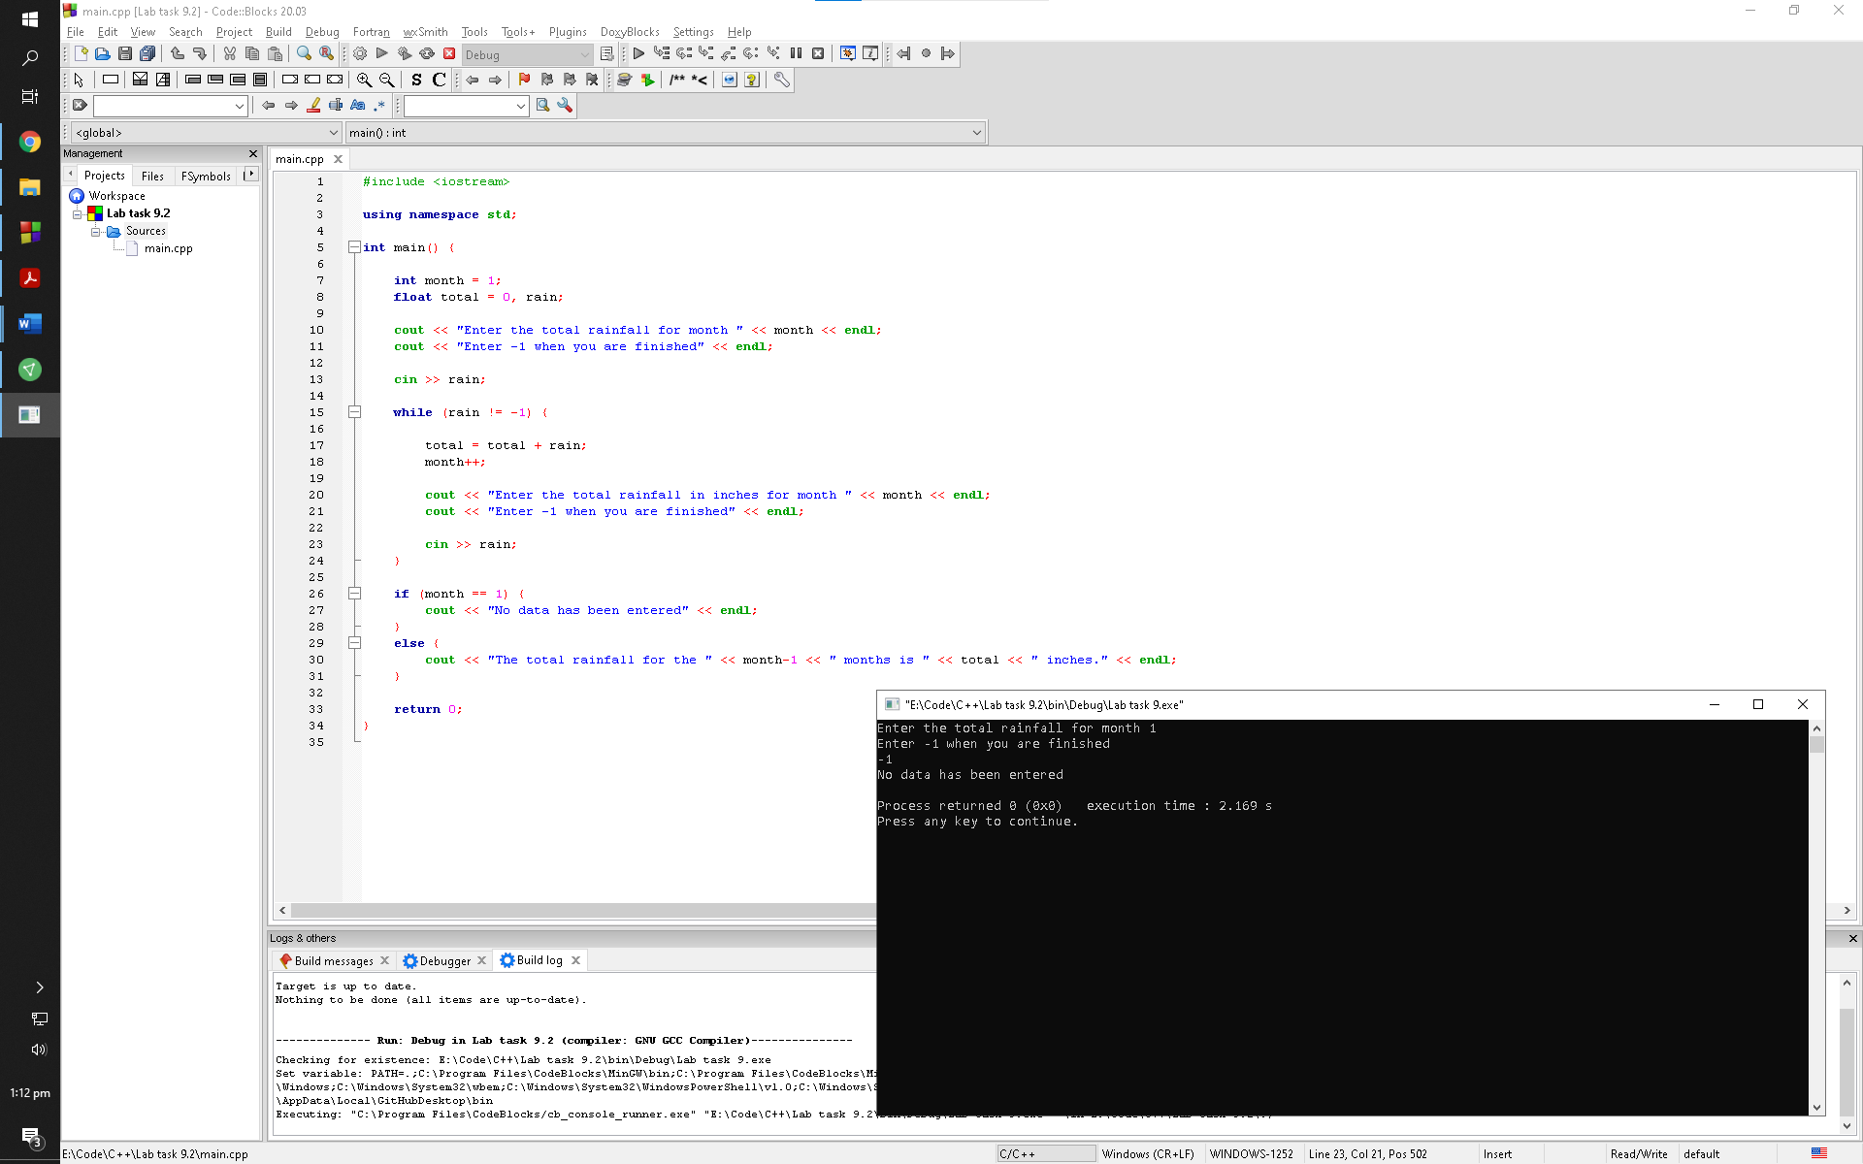

Observation: The program simply terminates and prompts the user with the cout statement within the if statement

What happens if you enter only values of 0 for one or more months?

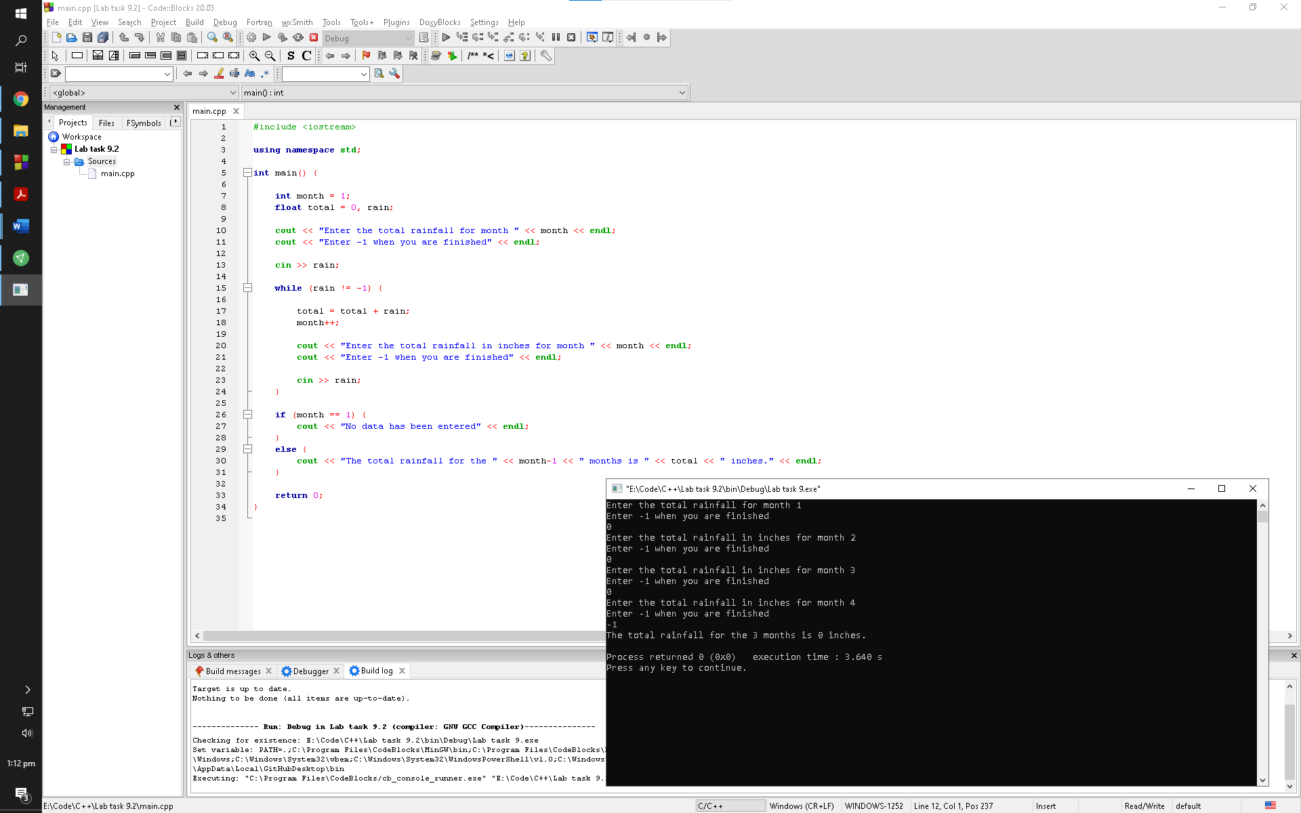

Observation: The program adds all of the zeros together and prompts the user with the total rainfall with respect to the months he/she entered the values of

Is there any numeri-cal data that you should not enter?

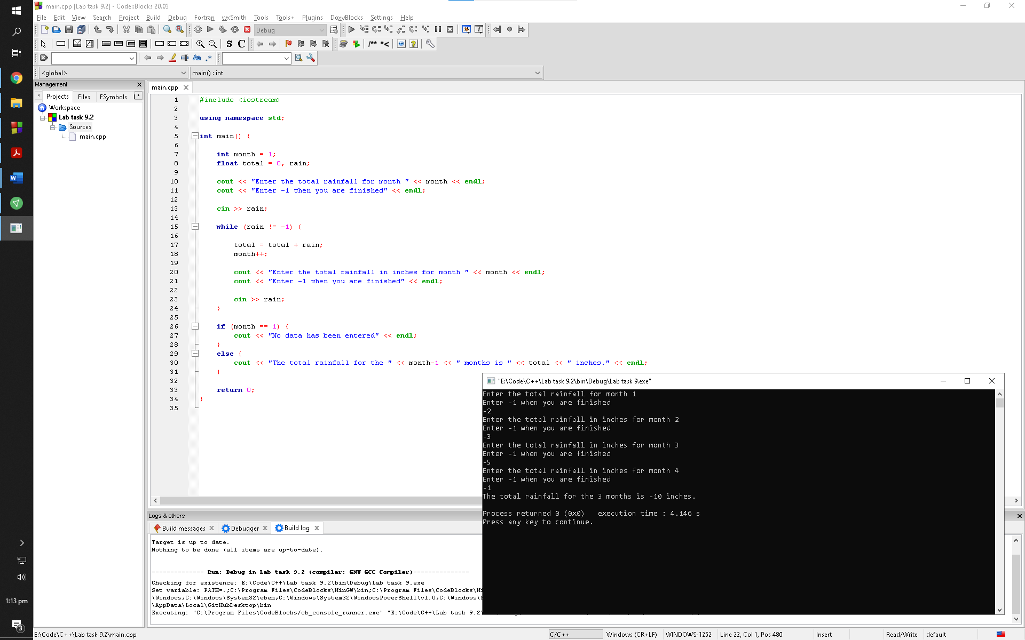

Observation: There is no limitation with the amount of rainfall you can enter in this program but working with negative numbers reminds you that rainfall in negative isn’t physically possible hence this is a humanly logic error

Exercise 6:

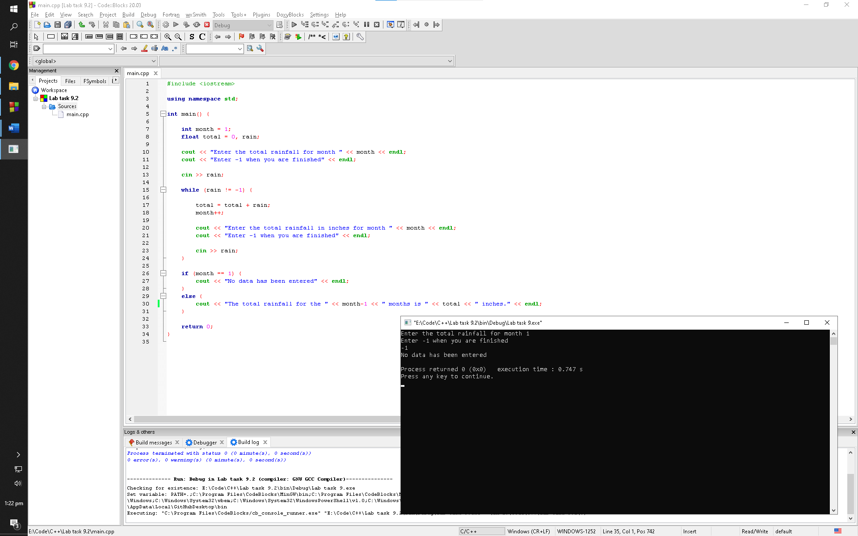

Observation: The if statement has the purpose of prompting the user when the user aborts the program without entering any rainfall value. The month variable is already initialized with 1 hence the program does not have to do anything

Lab task 9.3

Exercise 1:

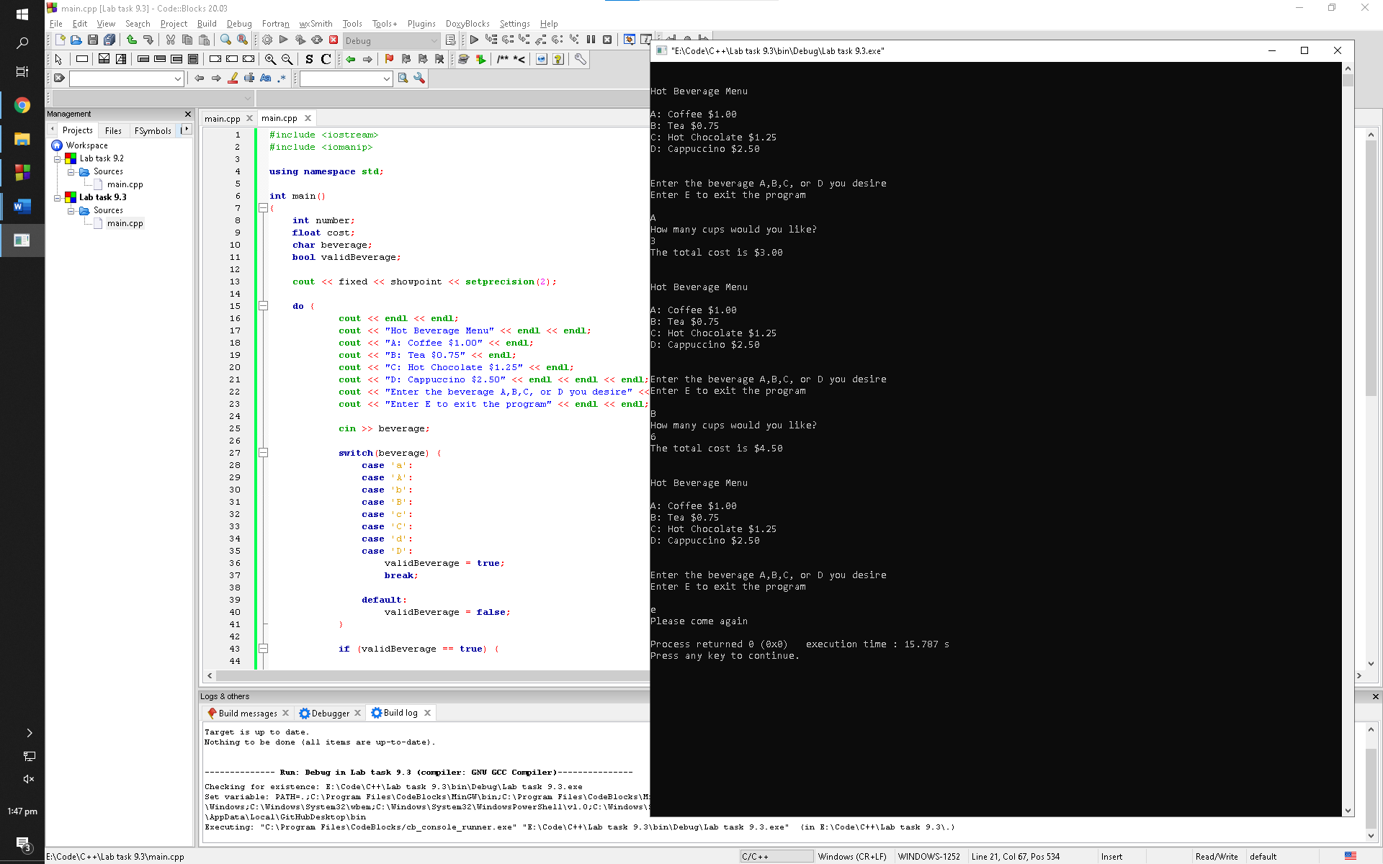

Observation: The program asks the user for the beverage they would like to purchase; it then asks the user for the number of cups they would like. The program then calculates the bill for the user depending upon the choices they have made

Exercise 2:

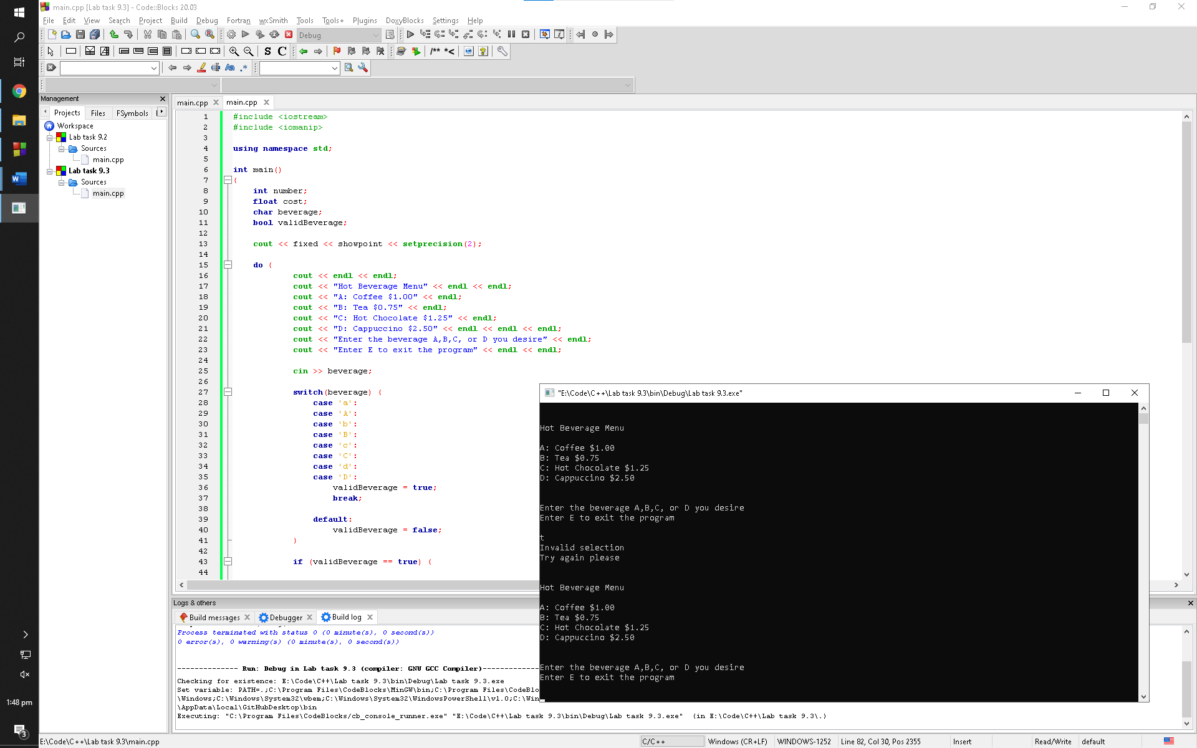

Observation: The program keeps looping forever since the user is entering invalid characters

Exercise 3

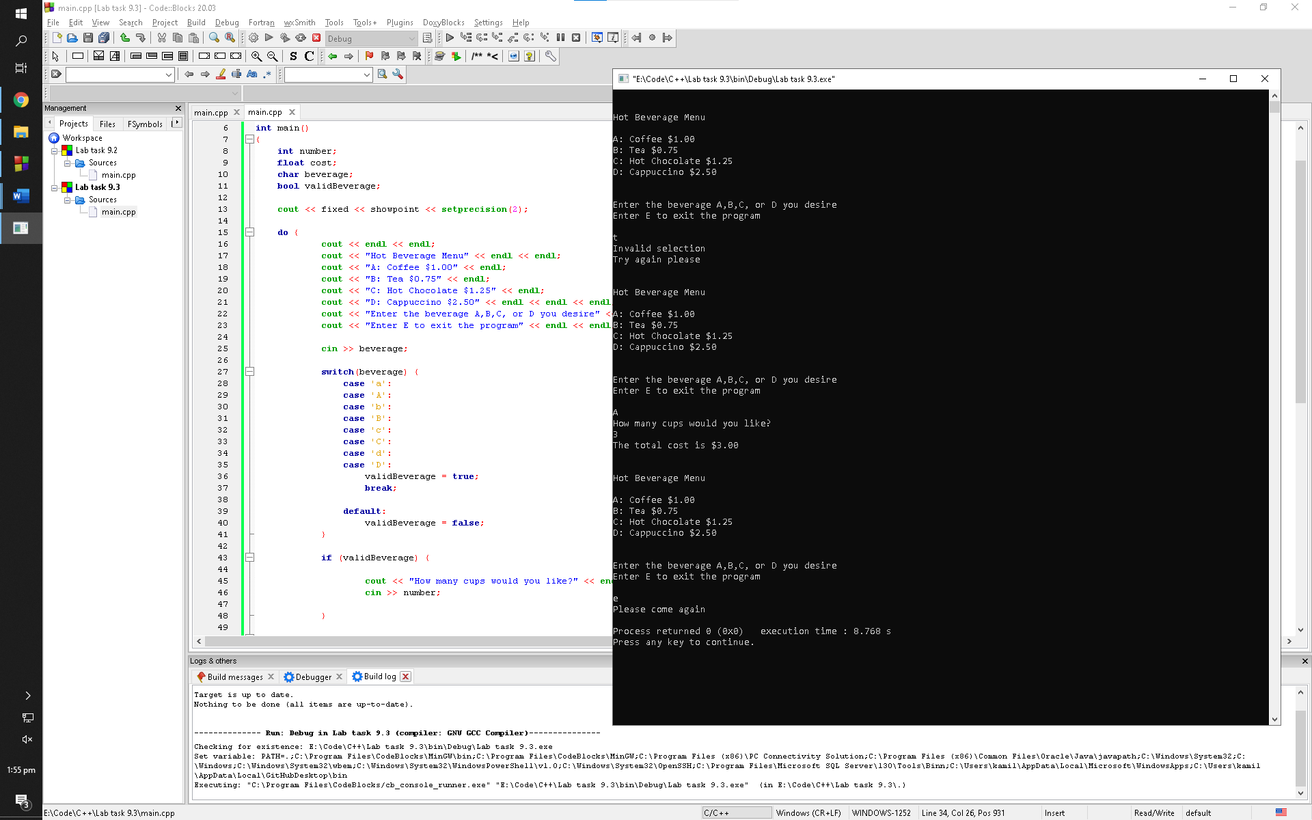

Observation: The condition acts the same since the default consideration is true when working with Boolean variables

Post lab

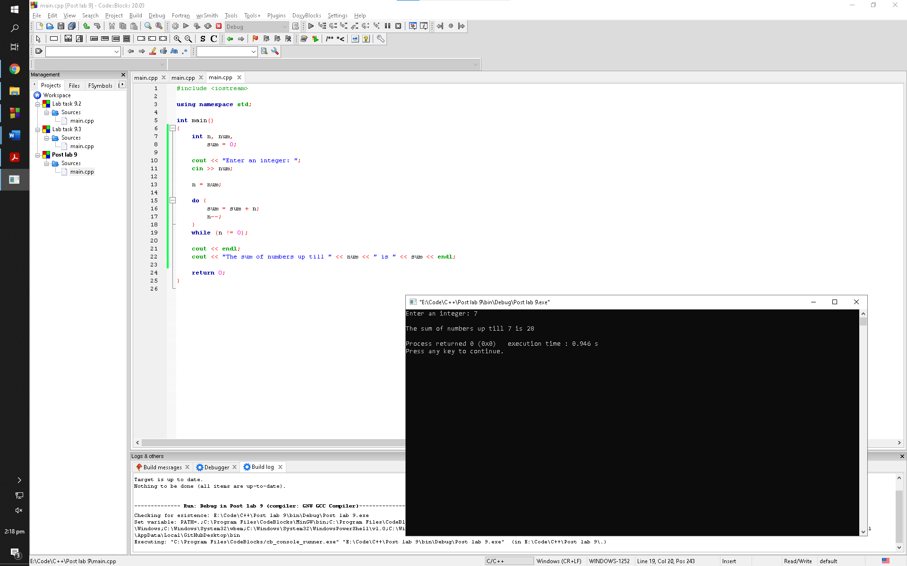

Observation: The program asks the user for the number up till what the user wants to add number to. The program then add all the leading integers to that number using do while loop and then prompts the user with the sum when it aborts that loop